**DAY-8(12-12-2023)-PYTHON**

**Introduction to Python**

* **P**ython is an interpreted, high level, dynamic programming language which has all the patterns of other programming languages like structural, object oriented and procedural language.
* Python was developed by Guido van Rossum  in 1991.
* It has prominent features than other languages like

1. **Code Readability:** User can easily understand the code by reading those lines.
2. **Kind of English Language:**The way you write Python code is a bit like writing in English, which makes it simpler to learn.
3. **Good at many Things:** we can make use of lot things like developing websites,working with data and in machine learning also for prediction.
4. **Free and Open Source:**It can easily downloaded and used.

**Python Implementations:**

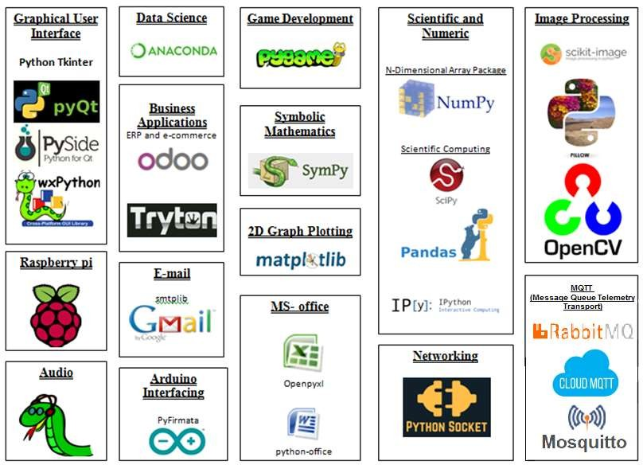

Python has different versions which are upgrading from the version Python 1.0 it is released into the market. Right now Python 3.11 latest version is available.

**Python Web Development Frameworks:**

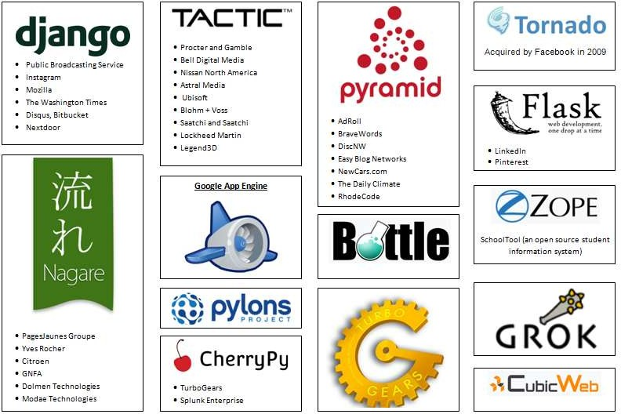

Python has powerful Libraries like matlab and numpy and pandas.

Through python Idle we will work in python.

**My first Python Program:**

* By make use of .py extension we save our programs in python.
* By using print() function we display the output.
* By using input() function we take input from keyboard.

Ex:

name=input(“enter your name”)

print(“welcome ”+name)

based on the input that uh give ,it will print output.For instance I take name input “Aparna”.The final output is “welcome Aparna”.

**Python Keywords and Identifiers:**

**Keywords**: These are reserved words which has already meaning So we cannot use as variables.

Ex: if, else, try,except,finally etc.

**Identifiers:** Giving the unique name to the variable to identify the things.

Ex: a=20,b=20 ,Here a,b acts as variable and an identifier also.

**Variable:** Which is the container to store values in python.

**Python Datatypes:**

* **Numbers(Integer and Float):**these are integer and float types.
* **String:**These are the string type data.
* **List (Array):**Which contain different types of elements which mutable.
* **Tuple (Constant Array):** which is immutable once declared we cannot change the data in it.
* **Dictionary:**which contain key-value pairs.

**Boolean data Type:** Which is of yes or no type values exactly contains True and False

**Ex:**

Process1=True

Process2=False